C.V. of

*****

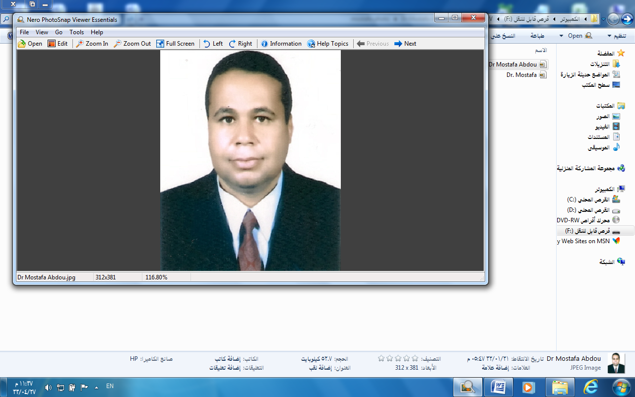

Dr. Mostafa Abdou Abd El-Naiem Mahmoud

******

Assistance Prof. of Soil Mechanics and Foundations

Faculty of Engineering, Assiut university, Egypt

Dr. Mostafa Abdou Abd EL-Naiem Mahmoud
- Civil Engineering Dept., Faculty of Eng., Assiut University, Assiut, Egypt.
- Phone : Handy : +2-016-4707505,
Work : +2-088-2411184,
Home : +2-088-2365756
- Email : mostafaabdo@yahoo.com
************************************************************************

Education:
- Ph.D. in Civil Engineering, Innsbruck University, Austria, ( Jully, 2003 ).
  - Dissertation : "Soil-Tunnel interaction under Earthquake Loads in Time
Domain" , (August, 1999 – Jully, 2003 ).

- M.Sc. in Civil Engineering, Assiut University, Egypt, ( April, 1995 ).
  - Thesis : " Investigation of the Distribution of Earth Pressure on Caissons
and Shells " , ( October, 1991 – April, 1995 ).

- B.Sc. in Civil Engineering, Assiut University, Egypt, ( June, 1989 ).
  - Average grade : " Distinction with honor's degree ".

************************************************************************

Experience :
- Demonstrator : ( Nov., 1989 – Jan., 1990 + March, 1991, - April, 1995 ).
Dept. of Civil Engineering, Assiut University, Egypt.

- Assistance Lecturer : ( April, 1995 – August, 1999 ).
Dept. of Civil Engineering, Assiut University, Egypt.

- Lecturer: ( Sept., 2003 – May, 2009 ) : [ Full-time].
Dept. of Civil Engineering, Assiut University, Egypt.
- Associate Professor: ( June, 2009 – Present ) : [ Full-time].
Dept. of Civil Engineering, Assiut University, Egypt.

***************************************************************
1. Tought Postgraduate Courses on :
- Advanced Soil Mechanics and Foundations
- Foundations on Problematic Soil
- Soil Mechanics and Foundations
- Currently co-supervising the research/M.S. thesis work for Master student on:

- Study on Pile Resistance Using Osterberg Cell

- Taught undergraduate courses on: (Lecturer)

- Soil Mechanics and Foundations
- Advanced Foundations
- Geotechnical Engineering
- Advanced Foundations
- Theory of Structures

- Supervised B. S. graduation project on:

- Foundations Project
***********************************************************

- Co-designed (within a Consultant Office):

Co-designed the following projects for ALUMINUM COMPANY OF EGYPT

- Butts Crushing
- Bath Material Recycling
- Butts Removal Station
- Thimble Removal Station
- Casting Station
- Shot Blasting Machine for Stubs
- 11KV Switchgear Room
- Silos of Bath Material Recycling
- New Chambers Cells
- Pumps House
- Electrical Building
- New Cooling Station
- Design of Buildings
- Design of Retaining Walls
- Design of Sheet piles
*************************************************************

- Member of Studying and Consultant Engineering Centre
( Faculty of Eng., Assiut University):

Actively participated in the Committees of Studying and Consultant
Engineering Centre To prepare the following:

- Analysis of Borings
- Carry all laboratory tests of soil mechanics
- Carry the field test related to soil mechanics and foundations
- Design of foundations
- Design of retaining walls
- Design of sheet piles
- Design of system of dewatering
- Following and checking the Compaction of replacement soil layers
under footings
- Investigation and Check of buildings
************************************************************

- Teaching Assistant (03/91-06/99): [ Full-time ]

Dept. of Civil Engineering, Assiut University, Assiut, Egypt.

. Taught undergrad. courses on:

- Soil Mechanics and Foundations (1)
- Soil Mechanics and Foundations (2)
- Theory of Structures
- Reinforced Concrete
- Construction Management
- Foundations Projects

************************************************************
8. HONORS:
- Top of the B.S. graduating class (Civil Eng.) of Assiut University in the
academic year 88/89, ( 220 Student )

- Awarded Govt. of Egypt National Merit Scholarship for the academic
years 84/85, 86/87- 88/89.
***********************************************************

9. PUBLICATION

- Fathalla M. El-Amin, Ebraheem H. Ramadan, El-Shrif M. Abdel-Aziz, and Mostafa A. Abd El-Naiem, “Investigation of the Distribution of Earth Pressure on Rigid Cylindrical Caissons”, Civil Engineering Research Magazine, Al-Azhar University, Vol. 17, No. 3, (1995).
- Fathalla M. El-Amin, Ebraheem H. Ramadan, El-Shrif M. Abdel-Aziz, and Mostafa A. Abdel-Naiem, “Investigation of the Distribution of Lateral Pressure on Rigid Cylindrical Caissons from Surcharge Loads”, Engineering Research Journal, Faculty of Eng. & Tech., Mataria, Helwan University, Vol. 46, December, (1995).
- Swoboda G., Mostafa A. Abd El-Naiem, and Hladik I., “Simulation of Initial Stresses for Tunnel Models”, Computer Methods and Advances in Geomechanics, Desai et al. (eds), Rotterdam, Balkema, pp. 703-707, (2001).
- Swoboda G. and Mostafa A. Abd El-Naiem, “Simulation and Behavior of Soil-Tunnel Lining under Dynamic Loads”, Numerical Methods in Geotechnical Engineering, Mestat (ed.), Paris, pp. 623-630, (2002).
- Swoboda G. and Mostafa A. Abd El-Naiem, “Simulation of Boundary Conditions on Soil-Tunnel Interaction under Seismic Loads in Time Domain”, 1st International Conference of Civil Engineering Science (ICCES1), Assiut, Egypt, pp. 1 –12, October (2003).
- Mohamed A.-B. Abdo and Mostafa A. Abd El-Naiem, “Reliability of Using High-Order Mode Shapes in Structural Damage Detection”, Journal of Engineering Sciences, Faculty of Engineering, University of Assiut, Vol. 33, no.6, pp. 2051–2068, November (2005).
- Mohamed H. Hussein, Mostafa A. Abd El-Naiem, and Ahmed R. Towfeek, “Study on Single Pile Resistance Using Osterberg Cell”, The Egyptian Geotechnical Society, Part 1, Vol. 17, (2006).
- Mostafa A. Abd El-Naiem, “Effect of Damping on the Behavior of Tunnel Lining Under Seismic Loads”, Journal of Engineering Sciences, Faculty of Engineering, Assiut University, Vol. 34, No. 6, pp. 1727-1742, November (2006).
- Mohamed H. Hussein, Mostafa A. Abd El-Naiem, and Ahmed R. Towfeek, “Investigation of Shaft and Base Resistance of a Single Bored Pile Using Osterberg Cell”, Journal of Engineering Sciences, Faculty of Engineering, Assiut University, Vol. 35, No. 4, pp. 853-867, July (2007).
- Mostafa A. Abd El-Naiem and Walid A. Mohamed, “Behavior of Existing Tunnel due to the Construction of a New Tunnel Passed Parallel Under it”, Journal of Engineering Sciences, Faculty of Engineering, Assiut University, Vol. 35, No. 6, pp. 1381-1400, November (2007).
- Mostafa A. Abd El-Naiem, “Behavior of Stabilizing Slopes With Sand Trench in Cohesive Soil due to Strip Footing”, Journal of Engineering Sciences, Faculty of Engineering, Assiut University, Vol. 36, No. 2, March (2008).
- Walid A. Mohamed and Mostafa A. Abd El-Naiem, “Seismic Evaluation and Retrofit of an Asymmetric Reinforced Concrete Flat Slab Building”, Journal of Engineering Sciences, Faculty of Engineering, Assiut University, Vol. 36, No. 2, March (2008).
- Mostafa A. Abd El-Naiem, “Prediction of Angle of Internal Friction of Sand Using Grain-Size Distribution Curve”, Journal of Engineering Sciences, Faculty of Engineering, Assiut University, Vol. (36), No. 3, May (2008).
- Mostafa A. Abd El-Naiem and Mohamed A.-B. Abdo “Effect of Soft Clay layer on Behavior of Tunnel Lining Constructed in Layered Soil”, Journal of Engineering Sciences, Faculty of Engineering, Assiut University, Vol. 38, No. 5, pp. 1101- 1117, september (2010).

- Mostafa A. Abdel Naiem Mahmoud, “Reliability of Using Standard Penetration Test (SPT) in Predicting Properties of Silty Clay With Sand Soil”, International Journal of Civil and Structural Engineering, Vol. (3), No. 3, pp. 545-556, (2013).
- Mostafa A. Abdel Naiem Mahmoud, “Correlation of Sandstone Rock Properties Obtained From Field and Laboratory Tests”, International Journal of Civil and Structural Engineering, Vol. (4), No. 1, pp. 1-12, (2013)
- Mostafa A. Abd El-Naiem, “Improving Behavior of Tunnel lining Constructed in Layered Soil Including Soft Clay Layer Using Stone Columns” , Arabian Journal for Science and Engineering, Springer, Vol. (38), No. 12, pp. 3289-3300, (2013).

************************

Dr. Mostafa A.A. Mahmoud

